1. **CNS anatomy**

* **Neurons**:
  + **Unipolar** (one axon, cell body to the side), **bipolar** (one axon one dendrite, cell body in the middle), **multipolar** (multiple dendrite one axon)
  + **Afferent neurons** (unipolar), **efferent neurons** (multipolar), and **interneurons** (bipolar, 99% of our neurons are interneurons within the CNS)
* **Glial cells** (neuroglia): ~90% of the cells within the CNS, supports the neurons
  + **Astrocytes**: primary support, many functions
    - Physical support
    - Scaffold during fetal brain development
    - Induce formation of blood–brain barrier
    - Form neural scar tissue
    - Take up and degrade released neurotransmitters
    - Take up excess K to help maintain proper ion concentration
    - Enhance synapse formation and strengthen synaptic transmission
  + **Oligodendrocytes**: Form myelin sheaths in CNS
    - Like Schwann cells in PNS
  + **Microglia**: Defence for brain (immune cells, phagocytic scavengers)
  + **Ependymal**: Line internal cavities; form cerebrospinal fluid; neural stem cell
  + Astrocytes and oligodendrocytes inhibit regeneration
* **Neuronal connections** (synapses)
  + **Convergence** (receive from multiple neurons) and **divergence** (send to multiple)
  + **Electrical** (no delay, gap junctions – bidirectional, only excitatory) vs **chemical** synapses (neurotransmitters, unidirectional, excitatory and inhibitory)

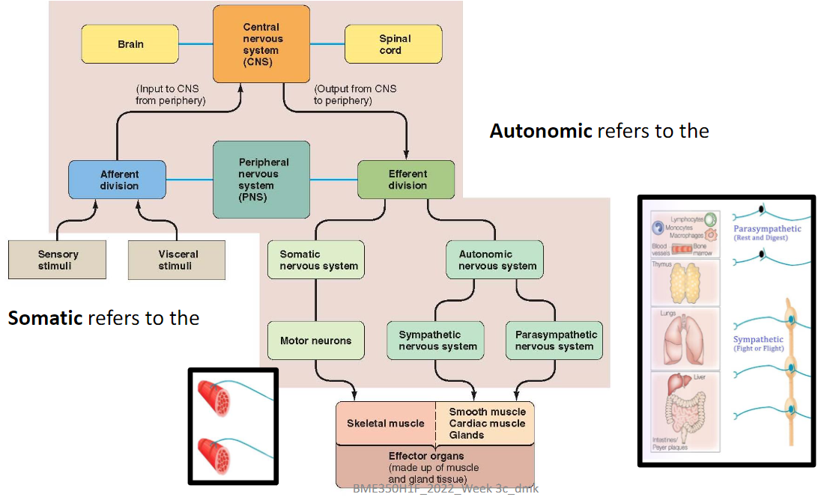

1. **Function of the brain**

* **Brain**: maintain homeostasis; has over 100 billion neurons and synapses
  + **Brain stem**: oldest in evolution, unconscious
    - 3 regions: **Midbrain**, **pons**, and **medulla**
    - Essential for living (heart, respiratory, sleep …)
    - Where the 12 cranial nerves arise (except vagus)
  + **Cerebellum**: coordination and balance, movement
  + **Forebrain**:
    - **Diencephalon** (interbrain):
      * **Hypothalamus**: homeostasis, ANS coordination
      * **Thalamus**: relay station, direct station towards stimuli, sensation
    - **Cerebrum**: more convoluted in advanced vertebrates, 80% brain weight
      * **Basal ganglia / nuclei**: group of cell bodies within cerebral grey matter, motor control, coordination
      * **Cerebral cortex**: complex, many functions including thinking
        + Left: logical, math, language skills
        + Right: non-language skills, perception, art
        + Right and left hemispheres connected by **corpus callosum** (thick band consisting of ~300 million neuronal axons travelling between the two hemispheres)
      * Brain **plasticity**
  + Diagram

    Description automatically generated**Limbic system**: structures that encircle brains stem (hypothalamus, part of forebrain); controls emotion, behavioural patterns, motivation for learning
* 4 lobes:
  + **Frontal**: motor
  + **Parietal**: sensing
  + **Occipital**: visual
  + **Temporal**: audio
* **Somatosensory** **cortex**:
  + Front of parietal lobe
  + Somatosensory homunculus: lips, hands, feet, and genitals greatest representation
* **Primary motor cortex**:
  + Back of frontal lobe, close to somatosensory cortex
  + Voluntary muscle control
  + Diagram

    Description automatically generatedMotor homunculus: similar to sensory

1. **Function of the spinal cord**

* Spinal cord structure: spinal nerve protected by vertebral column
  + 8 pairs of **cervical** (neck, namely C1–C8), 12 **thoracic** (chest), 5 **lumbar** (abdominal), 5 **sacral** (pelvic), and 1 **coccygeal** (tailbone) nerve; total 31
  + **Grey matter**: primarily cell bodies & dendrites, short interneurons, and glial cells
    - **Dorsal** **horn**: cell bodies of interneurons (afferent pathway, posterior)
    - **Ventral** **horn**: cell bodies of somatic efferent neurons (motor, anterior)
    - **Lateral horn**: cell bodies of automatic efferent neurons (nerves supply cardiac, smooth muscle and exocrine glands)
  + **White matter**: long interneurons axons organized tracts of similar functions, myelinated (grey is unmyelinated)
    - Nerves**:** bundles of axons
    - Tracts**:** bundles of neurons, consist of ordered neurons
    - **Ascending tract**: up, carry info to brain, terminates at cerebellum
      * First order: afferent, sensory to spine
      * Second order: spine to brain thalamus, crosses over
      * Third order: thalamus to primary somatosensory cortex
    - **Descending tract:** down, carry info down to skeletal muscles
      * Upper motor neurons: primary motor cortex to spine, crosses over
      * Lower motor neurons: spine to muscles, efferent
  + Diagram

    Description automatically generated**Dorsal root ganglion**: afferent neuron cell bodies, ganglion is collection of neuronal cell bodies located outside the CNS
* **Reflex**: activity between afferent input and efferent output without involving the brain
  + **Simple** **reflexes** (basic, instinct) vs **acquired reflexes** (conditioned, learned)
  + **Reflex arc**:
    - **Receptor**: responds to a **stimulus**
    - **Afferent pathway**: relayed to integrating centre (spine)
    - **Integrating centre**: CNS, spinal cord and brain stem integrate basic reflexes, higher brain levels process acquired reflexes
    - **Efferent pathway**: transmit instructions to effector
    - **Effector**: carry out responses
  + Types of reflexes:
    - **Stretch reflex**: **monosynaptic**, stretch-detecting receptor directly connector to effector to counter the stretch (contract the same muscle)
      * Knee jerk, essential for standing straight under gravity
      * **Reciprocal innervation**: relaxes opposite muscle, reciprocal path involves interneuron
    - **Withdrawal reflex**: polysynaptic, spinal reflex (all transmissions done in spinal cord), can be overridden voluntarily, 3 parts (Ex. Hand on fire)
      * Contract muscle to withdraw hand
      * Reciprocal innervation relaxes opposite muscle
      * Notify the brain
    - Golgi tendon reflex: prevents over-contraction, kind of opposite to stretch but polysynaptic
    - Crossed extensor reflex: controls opposite side of body couple with withdraw reflex for posture / balance

1. **Protective mechanisms of the CNS**

* **Bony enclosure**: skull and vertebral column
* **Meninges**: 3 protective & nourishing membranes
  + Dura mater: tough, inelastic; 2 layers, contains dural / venous sinuses (Brian fluids) in between to be returned to the blood stream
  + Arachnoid mater: cobweb appearance; protrusions of arachnoid tissue (arachnoid villi) penetrate into the dural sinuses
  + Pia mater: innermost, fragile, can go deep into the brain to provide blood
* **Cerebrospinal fluid** (CSF): between arachnoid and pia (subarachnoid space)
  + **Extracellular fluid of CNS**
    - Excess CSF can damage brain
  + **One-way flow**, transport and wasted removal
  + Formed in choroid plexuses (masses of pia mater tissue that dip into pockets formed by ependymal cells), after formation, CSP
    - Flows through the four interconnected ventricles
    - Enters the subarachnoid space from the fourth ventricle
    - Flows between the meningeal layers over the entire surface of CNS
    - At upper regions of the brain, reabsorbed from the subarachnoid space into the venous blood through the arachnoid villi
* **Blood–brain barrier** (BBB): selectively permeable membrane, limit exchange between the blood and brain interstitial fluid(fluid one layer under CSF / under pia)
  + **Anatomic**: In brain capillaries cells are joined by tight junctions so nothing can be exchanged by passing between the cells
  + **Physiological**: since exchange can only happen through the cells, ions / big molecules cannot go through without carrier channels
* Blood supply is crucial: brain only does aerobic metabolism, also doesn’t store glucose
  + Without oxygen can only go for ~ 3 min
* Headaches: often caused by muscle contraction, no pain receptors in brain but in tissues around (meanings, cranial and spinal nerves, …)
* Brain freeze: coldness in upper jaw causing blood vessels to constrict in brain (to direct blood to warm up jaw) which is interpreted as pain